Steps to connect AS400 DB2

1. Install Squirrel Client.
2. Download jt400-0.jar
3. Open Squirrel client
4. There are two tabs vertically aligned in left side. Drivers and Aliases

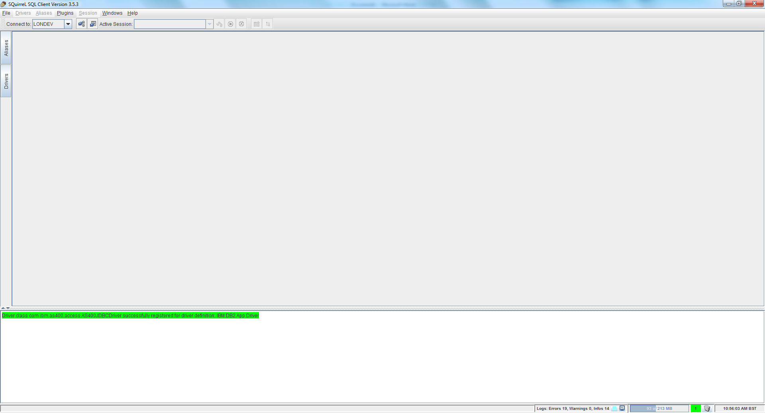

1. Select Drivers Tab

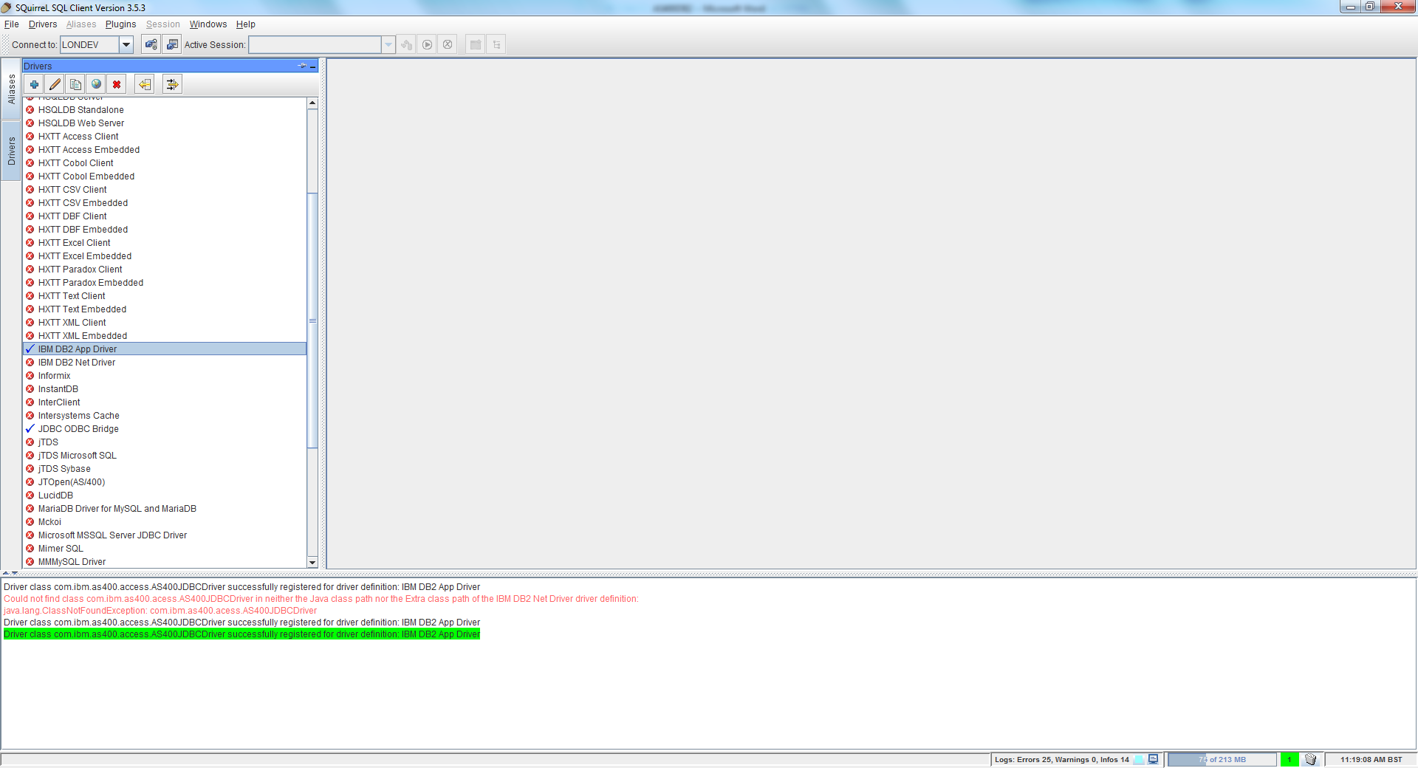

6) Select IBM DB2 APP Driver and double click from the previous screen. The below popup will be opened

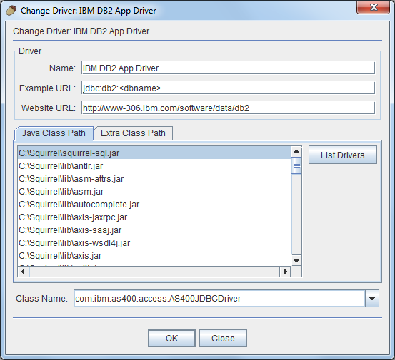

1. Select Extra Class Path tab from the popup window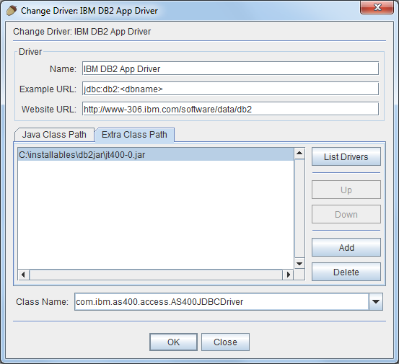
2. Enter “com.ibm.as400.access.AS400JDBCDriver” value for Class Name
3. Click Add button to add the jar file which downloaded in second step
4. Click OK button.
5. Then Select Aliases Tab
6. Create a new Alias. The below popup will be opened

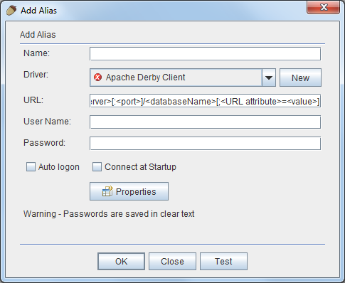

1. Select IBM DB2 App driver from Driver select box

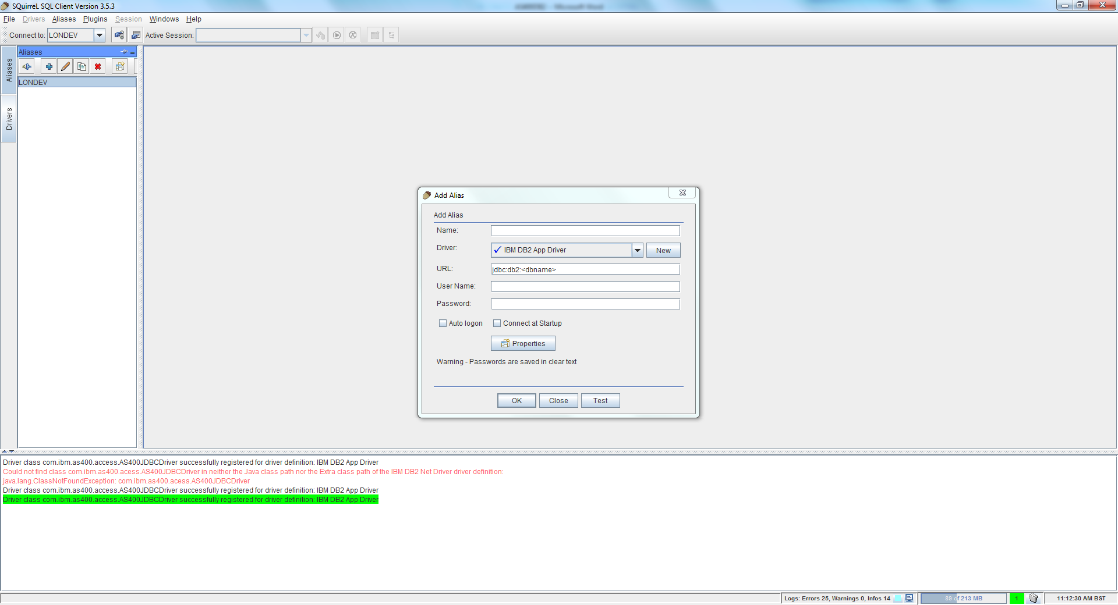

1. Provide “jdbc:as400://londev” to URL
2. Provide user name password as “webrev”

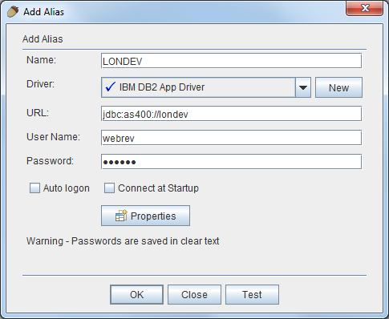

1. Test and Connect

